**OOAD USING JAVA LAB – 1**

**Name : Sanmat Sanjayakumar Payagoudar**

**SRN : PES1UG20CS385**

**Section : G**

**Use case diagram for UID number Automation System :**

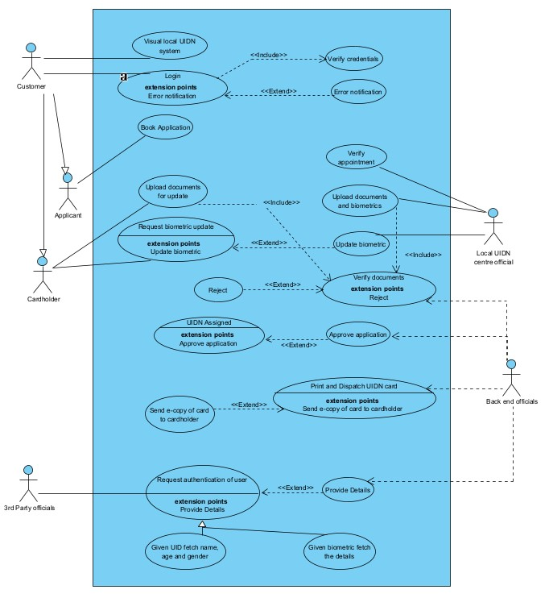

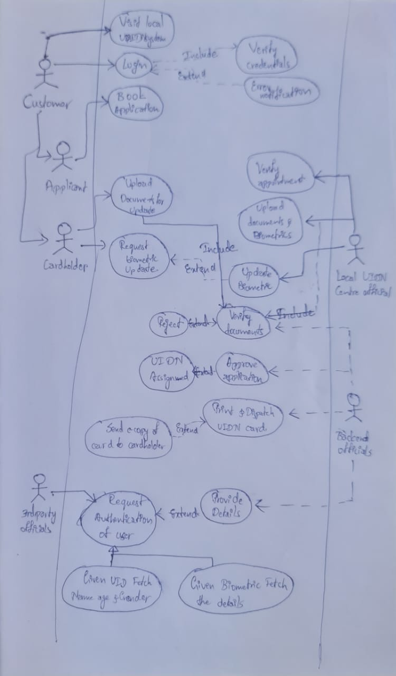

Name: Verify Docs

Summary/ Overview: The backend officials verify the documents and approve application which results in an UID number

Actor: Back-end Official

Pre Conditions: Official has to submit the documents to the backend official

Description:

Backend official receives documents from the official

He verifies the information in the documents

On successful verification he approves the application

He assigns a unique UID number to the applicant

Exceptions:

Wrong documents submitted

No documents submitted

Duplicate applications found

Alternate Flows:

Handles all the alternate paths

Name: Fetch basic details using UID

Summary/ Overview: Given an UID number, fetch basic details like Name, Age, and Gender etc.

Actor: Third Party

Pre Conditions: Correct UID number of user must be provided to third party

Description:

There must exist a UID for every user

Fetch details like Name, Age and Gender

These details will be used to Authenticate the user

Exceptions:

Wrong UID number for the user

Details do not match the user

Actors:

Applicant: initiates the process by logging in to the system and booking an appointment to visit a local UIDN center.

UIDN center official: verifies the applicant's appointment, uploads the applicant's documents and biometrics to the system, and initiates updates to biometric details as needed.

Backend official: verifies the applicant's documents and approves the application, assigns an UID number, and processes requests for updates to the applicant's details.

Third-party organization: requests authentication of the user by providing an UID number or a biometric fingerprint.

Use Cases:

Book appointment: the applicant logs in to the system and books an appointment to visit a local UIDN center.

Verify appointment: the UIDN center official verifies the applicant's appointment.

Upload documents and biometrics: the UIDN center official uploads the applicant's documents and biometrics to the system.

Verify and approve application: the backend official verifies the applicant's documents and approves the application, assigns an UID number.

Print and dispatch card: the backend official prints and dispatches the UIDN card to the applicant, or sends an e-copy if requested.

Request updates: the cardholder requests updates to their details in the system.

Upload update documents: the cardholder uploads the required documents for updates other than biometric

Update biometrics: the cardholder visits the local UIDN center and the official initiates update to biometric details.

Request authentication: a third-party organization requests authentication of the user by providing an UID number or a biometric fingerprint.